Microsoft and Nokia
Name
Institutional affiliation
Date

In the years 2013-2014 Microsoft corporation made the news on the acquisition of the Nokia company in a deal that cost Microsoft corporation about eight billion dollars (Kalm et al., 2013). This acquisition was made between two very large and well-known technology companies. One of the companies, Microsoft Company, initially dealt in computing hardware, software, and accessories. The other company, the Nokia Company, dealt in mobile devices, software and all accessories related to them. The Microsoft Corporation has grown to become a cultural phenomenon, ranked among the largest technology companies in the world including big names as Apple Company and Samsung Company (Taeixeria, 2015). The core business of the Microsoft Corporation is the development, licensing and manufacture of software products. These include the operation systems, business applications, server applications, software development tools, and internet software technology as well as consumer applications. The company is under the able leadership of one of the wealthiest individuals in the world, a philanthropist and the most famous businessman Bill Gates (. Under his leadership, Microsoft Company has set standards and defined markets in a global business scale.
The Microsoft Company was founded by Bill Gates and his friend Paul Allen. In 1975, Bill Gates and Allen developed a partnership named Micro-soft. In 1976, the company tradename was registered. With a series of successful product launches that followed the extreme failure of their initial version of launches, the Microsoft Company came to dominate the software business market. The product launched in the year 1985, November, Microsoft Windows, became the core and the most revolutionary product Microsoft has launched (Ovide, 2013). This operating system is accountable for a large percentage of Microsoft revenues and sets the standard to the operating system market.
On the other hand, Nokia Company started not as a manufacturing company of mobile devices, their software and their accessories rather it doubled in the production of footwear, paper products, and vehicle tires before engaging in the wireless industry.
Nokia Corporation provides the service of mobile networking solutions. These solutions include software solutions, hardware solutions, and telecommunications operator services, solutions for enterprises and all related markets. The Nokia Corporation is a Finnish origin company founded by a mining engineer Fredrick Idestam in the year1865 when he established a pulp mill in Tampere and the second one in Nokia. Later in 1871, he formed a partnership with Leo Michelin called Nokia Ab (Singh, 2014). The company has engaged in many industries in over one hundred and fifty years of operation. The move that made Nokia Ab big was the investment into large-scale telecommunication technology development and licensing. It became a major contributor to the mobile telephony industry assisting in setting up the GSM, LTE 3G and the current 5G standards of telecommunications (Singh, 2014). It was also an internationally recognized vendor of Nokia series of mobile phones and smartphones.
Motive
The agreement had many reasons that it should have taken place and took place at the right time. The Microsoft Corporation had the desire to keep its momentum in its endeavor to own at least 15% of the mobile phone industry (Singh, 2014). The figures show that this was a good move in contrast to the Surface phone project that flopped and cost Microsoft about nine hundred million United States Dollar. Recent figures show that the child of the merger, the Microsoft Windows phone had the highest ever share of the market at 8% surpassing the BlackBerry Corporation (Kalm et al., 2013). In 2011 Microsoft declared the aim to own 15% of the mobile phone industry by 2018 making an incentive for the merger since a report from BGR showed 81.6% of the Windows Phone sales came from the Nokia Hardware (Kalm et al., 2013).
The control of the hardware would mean the improved integration of the software and the hardware of the Microsoft Windows phone as exemplified by Apple phone franchise. The move also meant that user experience would be more consistent developing customer loyalty and brand recognition. Giving good experience of the user of Microsoft products through their phones would mean that the customers would keep using more of the Microsoft products in what it seemed the Halo effect by Microsoft (Singh, 2014).
Impact
Microsoft took the Nokia franchise under its Microsoft mobile subsidiary. It took over Nokia’s devices and services business in what was known to be one among the largest merges in the technology world. The Nokia hit devices such as the Nokia Lumia, the Nokia Asha, and the Nokia X series were under the umbrella of Microsoft. Microsoft also took over the design teams, the supply chains, the employees, the company accessories, a large percentage of its manufacturing pants and all of Nokia developer relations (Ovide, 2013).
Microsoft maintained a lot of the staff in the agreement including the Chief Executive Officer that served Nokia Company and as its president. Stephen Elop now serves as the Vice president of the Microsoft devices group and reposts directly to the Chief Executive Officer of Microsoft Devices Group Satya Nadella. He majorly oversees hardware lineup of the Microsoft Devices Group including the Perceptive Pixel Products known as PPI, phone, tablets, Xbox, surface and all the accessories to this hardware lineup. This agreement also maintained the design team and the Nokia Company imaging team that was switched over to Microsoft (Teixeira, 2015).
In the agreement, Microsoft was let to control the IP agreements than Nokia has created. Additionally, it included the third party contacts that have been created about the devices of Nokia Company. This partnership and third-party agreement include the examples of Symbian company agreements with Nokia, the Qualcomm agreement with Nokia and many major Silicon Valley company agreements with Nokia Company. Microsoft also took on the services that were initially offered by the Nokia Company such as the stores, the mix radio and much more. However, in this acquisition, the mapping entity of Nokia was considered as a separate business and was therefore excluded in the acquisition deal. The acquisition also excluded most of the Nokia’s networks, its solutions, its patents, a large percentage of them, and also the Nokia CTO office was retained to ownership of Nokia Company (Ovide, 2013).
Also among the impact of the merger is the adaptation of the closed model of the product by Microsoft akin to the model utilized by Apple. The Microsoft company aims to introduce closed end-user products which upon its success ensure that the customers remain loyal to the products. In such a case the move would significantly increase the revenues of Microsoft company (Ali-Yrkkö, 2013).
Financial disclosure.
After the acquisition, Microsoft reported an increase of 18% on is revenues at the fourth quarter of its financial year 2014. It is worth noting that the cost of the merger hurt the profits of Microsoft Company. Microsoft got $23.4 billion as revenues in the last three months of the fiscal year after the acquisition of Nokia which was an 18% increase from $19.9 billion records of the third quarter. It, however, disclosed a $700 cost incurred in the purchase of the Nokia devices and services. Around $0.8 per share were incurred an operating loss of Nokia reducing the total net income to $4.6 billion (Singh, 2014). Microsoft also saw significant growth in enterprise software including a 14% rise in licenses provision revenues. 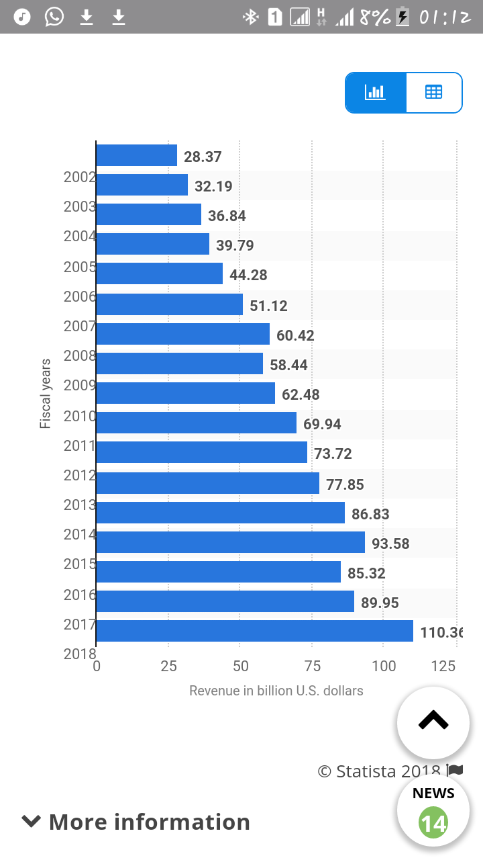
In financial disclosures, such combinations are accounted as acquisition and mergers. In such, the assets, liabilities, interest and the goodwill of the company being targeted must be reported. One company is usually identified as the acquiree and the other the acquirer. Purchase accounting is used to account for the standard changes that would occur due to the combination of two companies. Merger and acquisition accounting can also be used to account for the changes during the combination.

References
Ali-Yrkkö, J., Kalm, M., Pajarinen, M., Rouvinen, P., Seppälä, T., & Tahvanainen, A. J. (2013). Microsoft Acquires Nokia: Implications for the Two Companies and Finland. ETLA Brief, 16(3).
Singh, N. P. (2014). Microsoft Acquired Nokia in Unipolar Operating System Market. Independent Journal of Management & Production, 5(3), 598-622.
Teixeira, D. F. P. (2015). Microsoft-Nokia: stategy and valuation (Doctoral dissertation, Instituto Superior de Economia e Gestão)
Ovide, S. (2013). Deal is easy part for Microsoft and Nokia. Access: September.

